Multivariable Control Course 1 – State Space Model

# Exercise 1

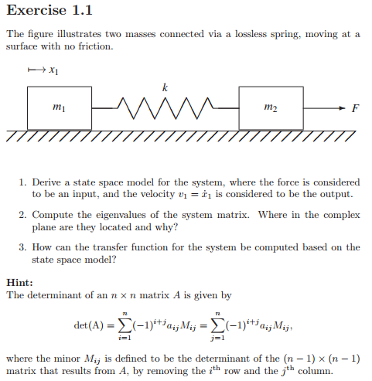

## 1.

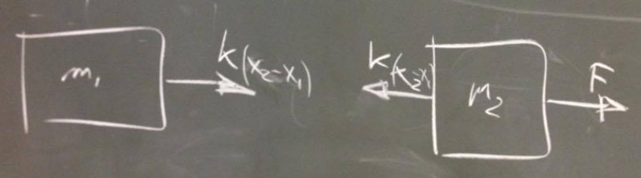

Equation 1:

Equation 2:

Equation 1:

Equation 2:

State Space part begins!

The equations

STATE SPACE! :D

Now we find the states! :D

Input:

Output:

Remember the Standard form!

4 states 4 equations to make it easier:

The First Part

The second part

An explanation on why the input does not have an effect on the output of the system.

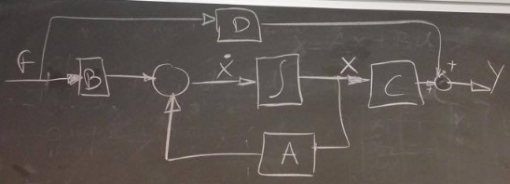

It is because the input does not have a DIRECT effect on the output it has to the system though.

## 2.

They are located in the left side since it is not an unstable system. The poles are only complex since there is no friction in the system, so it will continue to move for infinite. The string continuing making potential and kinetic energy.

The system matrix:

To find the poles, we need to find the eigenvalues of the system matrix.

The determinant is zero when IT IS NOT FULL RANK.

## 3.